Name: Parth Bansal  
Enrolment number: 21f3000805  
Email Id: [21f3000805@ds.study.iitm.ac.in](mailto:21f3000805@ds.study.iitm.ac.in)  
Video Link:

**Influencer Engagement & Sponsorship Coordination Platform - V2 (MAD-2)**

This web platform connects Sponsors and Influencers. Built on the Flask framework and VueJs, it offers a user-friendly interface for Sponsors to create campaigns to advertise their products or services. Influencers can earn money by accepting or creating offers for these campaigns. The platform also includes regular users who can follow Influencers, increasing their status on the platform. Additionally, an administrator monitors user activity and flags inappropriate campaigns.

**Features**

**Admin:**

**Dashboard**: This page will list administrator details, display information on the six most recent campaigns with options to view or flag/unflag them, and provide lists of active influencers, sponsors, and users, each with the option to delete.  
**View Campaigns**: Show details for all campaigns, with options to view or flag/unflag each campaign.  
**Insights**: This page will feature several pie charts illustrating the distribution of flagged versus unflagged campaigns, public versus private campaigns, user types (Admin, Influencer, Sponsor, User), and the status of campaigns (approved, pending, rejected). Additionally, it will include a bar chart showing the number of followers per influencer.

**Sponsor:**

**Dashboard**: lists sponsor detail and campaigns with all available actions. Sponsors can view, update, or delete campaigns, toggle visibility between public and private, and track campaign progress.  
**Update Dashboard**: Sponsors can update their details, including username, phone number, password, and industry.  
**Create Campaign**: This page allows sponsors to create campaigns by entering the title, description, start date, end date, budget, visibility, and goals.  
**Inbox**: This page lists all influencers the sponsor has communicated with, arranged in reverse chronological order. Each influencer card shows the last message and any budget or term negotiations, with a green dot indicating new messages. Sponsors can delete all messages for a particular influencer using the delete button on the card.  
**Inbox Chat**: This page displays conversations between the sponsor and influencers, including campaign names and any budget or term negotiations. Messages are marked with yellow, green, or red dots to indicate their status (Pending, Accepted, or Rejected). Messages from influencers appear on the left, and messages from sponsors on the right. Sponsors can send messages, select campaigns, and modify terms or budgets, as well as accept or reject collaboration requests. Each message shows whether it has been seen and the time it was sent.  
**Search Influencer**: lists all influencers with their details and provides the option to send requests about specific campaigns. Sponsors can sort influencers by category, niche, and number of followers.

**Influencer:**

**Dashboard**: This page lists the details of influencers.  
**Update Dashboard**: Influencers can update their details, including username, phone number, password, category, and niche.  
**Inbox**: This page lists all sponsors the influencer has communicated with, arranged in reverse chronological order. Each sponsor card displays the last message and any budget or term negotiations, with a green dot indicating new messages. Influencers can delete all messages for a particular sponsor using the delete button on the sponsor card.  
**Inbox Chat**: This page shows conversations between influencers and sponsors, including campaign names and any budget or term negotiations. Messages are marked with yellow, green, or red dots to indicate their status (Pending, Accepted, or Rejected). Messages from influencers appear on the right, and messages from sponsors on the left. Influencers can send messages, select campaigns, and modify terms or budgets, as well as accept or reject collaboration requests. Each message shows whether it has been seen and the time it was sent.  
**Search Campaigns**: This page lists all public campaigns with their details and allows influencers to send requests to sponsors about specific campaigns. Influencers can sort campaigns based on their start time and budget.

**User:**

**Dashboard**: This page lists user details and shows all the influencers the user follows, with an option to unfollow them.  
**Update Dashboard**: Users can update details like username, phone number, and password.  
**Search Influencer**: lists all influencers with their details and provides an option to follow them.

**Technology Stack:**

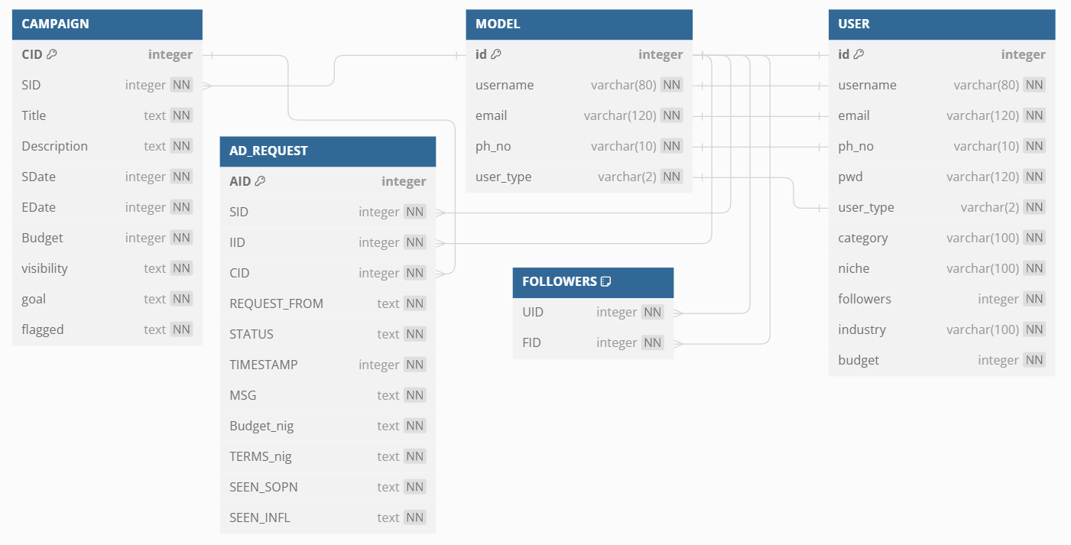**Flask Framework**: Flask is a lightweight web application framework in Python used for building the backend of the website. It is user-friendly and offers a variety of features, making it a great choice for web development.  
**VueJs: Vue.js is a progressive JavaScript framework for building user interfaces, enabling the development of dynamic, multi-page applications with ease.  
Redis: Redis is an in-memory data store used for caching and as a message broker, offering fast data access and efficient inter-service communication.  
Celery:** **Python-Celery is an asynchronous task queue library that handles background tasks and scheduling, enabling scalable and efficient task processing.**  
**SQLite Database**: SQLite3 is used for data storage, including user details, credentials, campaign information, ad requests, and follower data. It is a reliable, open-source database management system integrated with Python, ensuring easy setup and use.  
**Flask-JWT: Flask-JWT is a Flask extension for managing JSON Web Tokens (JWT), enabling secure authentication and access control in web applications.  
Flask-SQLAlchemy**: This extension integrates SQLAlchemy with Flask, simplifying database operations by setting up common patterns and objects, such as sessions, models, and engines.

Fig: ER diagram of the database.